 

## A Minor Project Report II on

DUAL AXIS SOLAR POWER TRACKER USING ARDIUNO

## Submitted by

**SHARANYA P (927622BEE105) POORVASANDHYA P (927622BEE081) SRINITHI K (927622BEE115)**

**PRAVEENM (927622BEE307)**



**DEPARTMENT OF ELECTRICAL AND ELECTRONICS ENGINEERING M.KUMARASAMY COLLEGE OF ENGINEERING**

(An Autonomous Institution Affiliated to Anna University, Chennai)THALAVAPALAYAM,KARUR-639113.

## MAY 2024

M. KUMARASAMY COLLEGE OF ENGINEERING

(Autonomous Institution, Affiliated to Anna University, Chennai)

# BONAFIDE CERTIFICATE

Certified that this Report titled **“DUAL AXIS SOLAR POWER TRACKER USING ARDUINO BOARD”** is the bonafide work of **SHARANYA P (927622BEE105), POORVASANDHYA P (927622BEE081) , SRINITHI K (927622BEE115),**

**PRAVEEN M (927622BEE307)** who carried out the work during the academic year (2023-2024) under my supervision. Certified further that to the best of my knowledge the work reported herein does not form part of any other project report.

#### SIGNATURE SIGNATURE

**SUPERVISOR HEADOFTHEDEPARTMENT**

Mr.S.DINESHKUMAR M.E., Dr.J.Uma M.E.,Ph.D.,

Assistant Professor Professor & Head

Department of Electricaland Electronics Engineering M.Kumarasamy College of Engineering, Karur

Department of Electrical and Electronics Engineering M.Kumarasamy College of Engineering, Karur

Submitted for Minor Project I (18EEP201L) viva-voce Examination held atM.KumarasamyCollegeofEngineering,Karur-639113on………………..

ii

## DECLARATION

We affirm that the Minor Project II report titled “**DUAL AXIS SOLAR POWER TRACKER USING ARDIUNO”** being submitted in partial fulfillment for the award of **Bachelor of Engineering in Electrical and Electronics Engineering** is the original work carried out by us.

|  |  |  |
| --- | --- | --- |
| **REG.NO** | **STUDENTNAME** | **SIGNATURE** |
| **927622BEE105** | **SHARANYA P** | **------------------------** |
| **927622BEE082** | **POORVASANDHYA P** | **------------------------** |
| **927622BEE115** | **SRINITHI K** | **------------------------** |
| **927622BEE307** | **PRAVEEN M** | **------------------------** |

iii

### VISION AND MISSION OF THE INSTITUTION

**VISION**

* To emerge as a leader among the top institutions in the field of technical education

### MISSION

* Produce smart technocrats with empirical knowledge who can surmount the global Challenges.
* Create a diverse, fully-engaged, learner-centric campus environment to provide Quality education to the students.
* Maintain mutually beneficial partnerships with our alumni, industry, and Professional associations.

### DEPARTMENT OF ELECTRICAL AND ELECTRONICS ENGINEERING VISION

To produce smart and dynamic professionals with profound theoretical and practical knowledge comparable with the best in the field.

### MISSION

* Produce hi-tech professionals in the field of Electrical and Electronics Engineering by inculcating core knowledge.
* Produce highly competent professionals with thrust on research.
* Provide personalized training to the students for enriching their skills.

### PROGRAMME EDUCATIONAL OBJECTIVES(PEOs)

* **PEO1:**Graduates will have flourishing career in the core areas of Electrical Engineering and also allied disciplines.
* **PEO2:**Graduates will pursue higher studies and succeed in academic/research careers
* **PEO3:**Graduates will be a successful entrepreneur in creating jobs related to Electrical and Electronics Engineering /allied disciplines.
* **PEO4:**Graduates will practice ethics and have habit of continuous learning for their success in the chosen career.

iv

**PROGRAMME OUTCOMES (POs)**

After the successful completion of the B.E. Electrical and Electronics Engineering degree program, the students will be able to:

**PO1: Engineering Knowledge:** Apply the knowledge of mathematics, science, engineering fundamentals, and an engineering specialization to the solution of complex engineering problems.

**PO2: Problem Analysis:** Identify, formulate, review research literature, and analyze complexengineering problems reaching substantiated conclusions using first principles of mathematics, natural sciences, and engineering sciences.

**PO3:Design/Development of solutions:**

Design solutions for Complex engineering problems and design system components or processesthat meet the specified needs with appropriate consideration for the public health and safety, and the cultural, societal and environmental considerations.

**PO4:Conduct Investigations of complex problems:** Use research-based knowledge and research methods including design of experiments, analysis and interpretation of data, and synthesis of the information to provide valid conclusions.

**PO5: Modern Tool Usage:** Create, select, and apply appropriate techniques, resources, andmodern engineering and IT tools including prediction and modeling to complex engineering activities with an understanding of the limitations.

**PO6:The Engineer and Society:** Apply reasoning in formed by the contextual knowledge to assess societal, health, safety, legal and cultural issues and the consequent responsibilities relevant to the professional engineering practice.

**PO7:Environment and Sustainability:** Understand the impact of the professional engineering solutions in societal and environmental contexts, and demonstrate the knowledge of, and need for sustainable development.

**PO8: Ethics:** Apply ethical principles and commit to professional ethics and responsibilities and norms of the engineering practice.

**PO9:Individual and Teamwork:** Function effectively as an individual, and as a member or leader in diverse teams, and in multi-disciplinary settings.

**PO10: Communication:** Communicate effectively on complex engineering activities with the engineering community and with society at large, such as, being able to comprehend and write effective reports and design documentation, make effective presentations, and give and receive clear instructions.

**PO11: Project Management and Finance:** Demonstrate knowledge and understanding of the engineering and management principles and apply these to one’s own work, as a member and leader n a team, to manage projects and in multi-disciplinary environments.

**PO12: Life-long learning:** Recognize the need for, and have the preparation and ability to engage in independent and life-long learning in the broadest context of technological change.

### PROGRAM SPECIFIC OUT COMES (PSOs)

The following are the Program Specific Outcomes of Engineering Students:

* **PSO1:**Apply the basic concepts of mathematics and science to analyse and design circuits, controls, Electrical machines and drives to solve complex problems.
* **PSO2:**Apply relevant models, resources and emerging tool sand techniques to provide solutions to power and energy related issues &challenges.
* **PSO3:**Design, Develop and implement methods and concepts to facilitate solutions for electrical and electronics engineering related real-world problems.

|  |  |
| --- | --- |
| **Abstract(Key Words)** | **Mapping of Pos and PSOs** |
| 1.Light Depending Resistor (LDR)  2.Solar tracker  3.Ardiuno Microcontroller  4.3-D dual axis model | PO1,PO2,PO3,PO4,PO5,PO6,PO7,  PO8,PO9,PO10,PO11,PO12,PSO1,  PSO2,PSO3. |

## [ACKNOWLEDGEMENT](https://www.google.com/search?rlz=1C1CHBD_enIN820IN820&q=ACKNOWLEDGEMENT&spell=1&sa=X&ved=0ahUKEwj99az1_ZXhAhVN63MBHRVODE4QkeECCCkoAA&cshid=1553265789884876)

Our sincere thanks to **Thiru.M.Kumarasamy, Chairman and Dr.K.Ramakrishnan B.E., Secretary** of **M.Kumarasamy College of Engineering** for providing extraordinary infrastructure, which helped us to complete the Minor project in time.

It is a great privilege for us to express our gratitude to our esteemed **Principal Dr.B.S.Murugan M.Tech., Ph.D.,** for providing us right ambiance for carrying out the project work.

We would like to thank our **Head of the Department Dr.J.Uma M.E., Ph.D., Department of Electrical and Electronics Engineering,** for her unwavering moral support through out the evolution of the project.

We would like to express my deep gratitude to our Minor Project Guide **Mr.S.Dinesh Kumar M.E., Assistant Professor, Department of Electrical and Electronics Engineering,** for his constant encouragement, kind co-operation, valuable suggestions and support rendered in making our project a success.

We offer our whole hearted thanks to our Minor project coordinator **Dr.B.Rajesh Kumar M.E., Ph.D.,, Department of Electrical and Electronics Engineering,** for his constant encouragement, kind co-operation and valuable suggestions for making our project a success.

We are glad to thank all the **Faculty Members** of **Department of Electrical and Electronics Engineering** for extending a warm helping hand and valuable suggestions through out the project.

Words are boundless to thank **Our Parents and Friends** for their constant encouragement to complete this Minor project successfully.

vii

# TABLE OF CONTENTS

|  |  |  |
| --- | --- | --- |
| **CHAPTER**  **NO** | **TITLE** | **PAGENO** |
|  | **ABSTRACT** | ix |
| **1** | **SURVEY FORM ANALYSIS** | 1 |
|  | 1.1 Name and Address of the Community | 2 |
|  | 1.2 Problem identification |  |
| **2** | **LITERATURE REVIEW** | 3 |
| **3** | **PROPOSED METHODOLOGY** |  |
|  | 3.1 Block Diagram |  |
|  | 3.2 Description |  |
|  | 3.3 Cost Estimation |  |
| **4** | **FUTURE SCOPE AND ITS IMPLEMENTATION PLAN** |  |
|  | **REFERENCES** |  |

viii

**ABSTRACT**

As population is increasing globally, rural peoples are very concerned for electricity. There are various ways of electricity generation like Hydro power plant, Nuclear power plant, Wind mill plant sand also solar power plants. Nowadays they have lots of power plants established on solar and Wind technology. Our project aims at Dual axis or Dual direction tracker. The solar panel used in this system can adjust its direction both in X-Y co- ordinates. This helps better directivity with sun rays, thus increasing the efficiency of the solar system. The world is now moving towards the renewable energy source due to various factors like pollution and cost of non-renewable energy sources. One of the major renewable energy sources is sun. The placing of solar panels at exact angle and direction according to the motion of sun maximize the efficiency of the system. As the angle of the sun varies throughout the day and seasons, this affects the amount of electricity a solar power system will generate.

Aurdino based on Dual axis solar power tracking system proposed in order to get maximum Solar energy. The aurdino is used to give command to rotate the solar panel. Solar trackers are used to improve the power gain from solar energy solar power changes due to the seasonal variation and tilting of earth which changes the position of the sun in the sky. The dual axis trackers can generate up to 40% more electricity than the unmovable solar Panel system that stay at a fixed position .This project will make use of the Light Depending Resistor (LDR) which is important to detect the sunlight by following the source of the sunlight location. Aurdino Uno microcontroller is used to control the motors based on LDR..The outcome of the solar tracker system has analyzed and compared with the fixed or static solar panel found better performance in terms of voltage, current and power. Therefore, the solar tracker is proved more practical for capturing the maximum sunlight supply for star harvesting applications.

ix

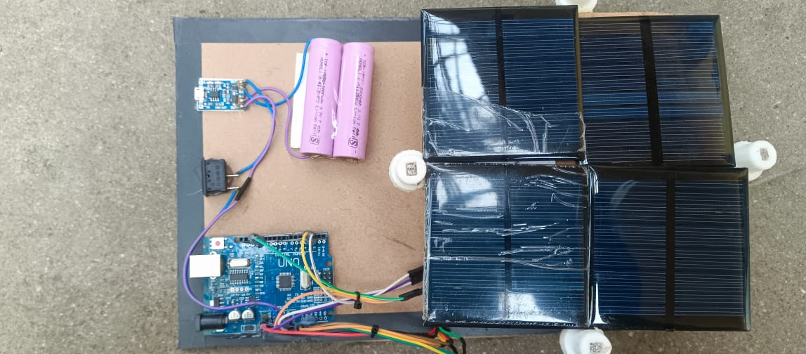

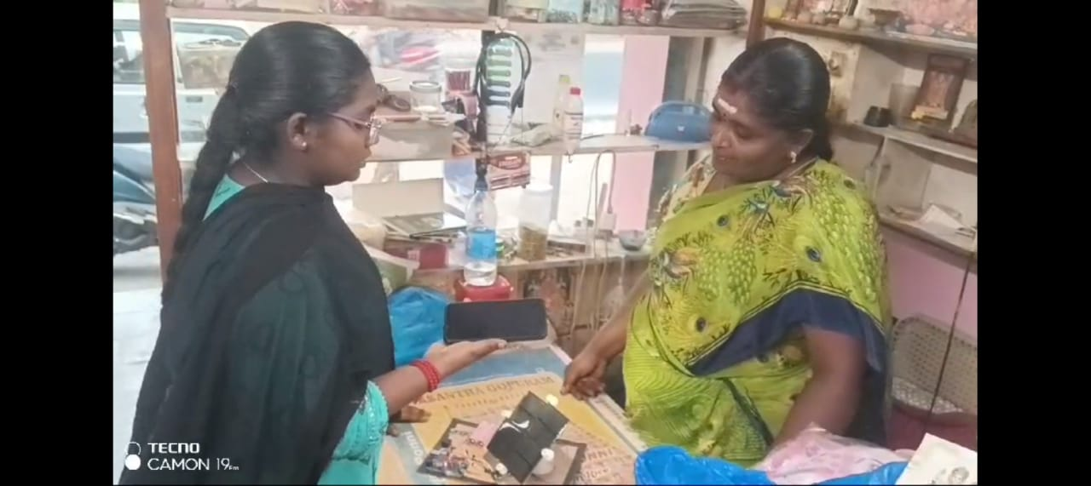

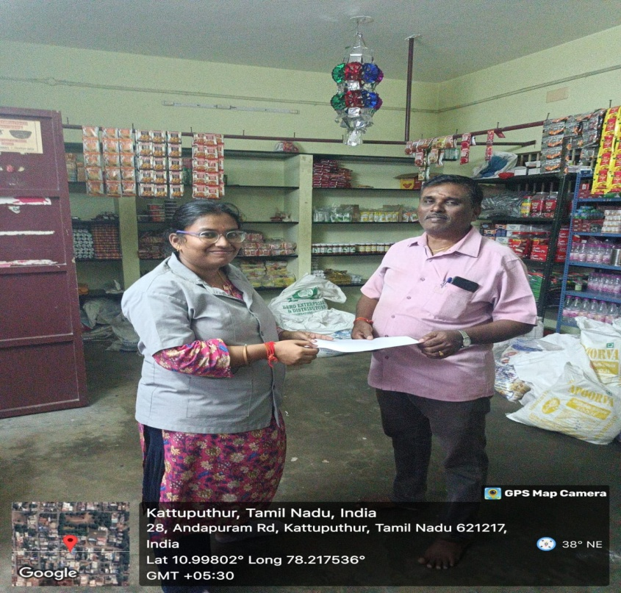

**Img 4.1-(1)-**Project overview

**(2)-**Implentation photo

**(3)-**geotag photo

**CHAPTER 1**

**SURVEY FORM ANALYSIS**

**1.1 NAME AND ADDRESS OF THE COMMUNITY:**

R.Murugan,

CP city centre, salem road,

RP Pudhur, Namakkal.

**1.2 PROBLEM IDENTIFICATION:**

The main goal is to keep solar PV panel perpendicular to the sun throughout the day in order to increase the energy generation. Dual axis solar tracking system can be an effective way to increase the efficiency of solar cells. The devastating problem on both biotic and abiotic components of our home (i.e. pollution) can be reduced by using solar energy as the major source for power generation. The natural gift like fossil fuels, woods, etc. which are limited in amount can be saved from crisis and extinction. For people, due to its more efficiency and less harmful impacts dual axis solar tracking system might be good decision for the intermediate future. So, this project can practically demonstrate effect of this variation to people.

**CHAPTER 2**

**LITERATURE REVIEW**

**Paper 1:** Aurdino based two axis solar tracking by servo mechanism

**Inference:** This study compares the energy conversion efficiency of

Photo modules with solar tracking system versus photo modules that

are fixed

**Author: wirfs-Brock,Jordan.**

**Paper 2:** Dual axis solar tracking system for maximum power using

Aurdino.

**Inference:**The power generation is not as efficient back then as it is

today since there are so many types of power generation system.

**Author: Urry J**

**Paper 3:** Development of Dual axis solar tracker with aurdino lab

view.

**Inference:**The paperconcludes by emphasizing the need for further

Research to develop more efficient and cost effective solar tracking

System to enhance the adoption of solar technology

**Author: Hsiang,Soloman**

**Paper 4:** An analytical approach to design a cost effective dual axis

Solar tracker based on CSP and PVT technology **.**

**Inference:** The author begin by discussing the importance of solar

Energy as a clean and renewable source of energy

**Author: Phillips ,Melissa C K.**

**Paper 5:** Microcontroller Based Dual Axis Sun Tracking System

for Maximum Solar Energy Generation.

**Inference 5:** The author discuss the advantage and disadvantage of

Each type of tracker and as well as the factor that affects its

Performance.

**Author:Griscom,Bronson**

**CHAPTER 3**

**PROPOSED METHODOLOGY**

**3.1 BLOCK DIAGRAM**

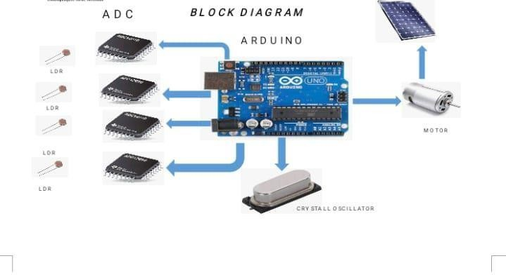

**Fig 3.1** Block diagram of dual axis power tracker

**3.2 DESCRIPTION**

The dual axis tracker collect energy from the sun from the east, west, north, and south angles. It functions on two axes primary and secondary. One axis helps the solar tracker to move from east to west and the other helps the tracker to move from north to south. Hence it is known as dual axis solar tracker. It can generate upto 40% more electricity than the unmovable solar panel systems that stay at a fixed position. Besides due to its movement in all directions dual axis tracker is quite flexible. The sun is tracked on two separate axes, utilizing two pivot points, so the panel may be turned around a full 360° in this method. In this kind of solar tracker system, the horizontal and vertical axes are typically both present. Although it needs a sophisticated control system, it is better than SAT. The dual-axis systems are characterized by the azimuth of their principal axes with relation to their ground. The best part about these trackers is that they move in all directions; they can supply more energy and long hours as they track the Sun’s movement. It does not wait for the sun’s rays to fall on the panels. Instead, the panels follow the Sun across the sky throughout the day. The dual axis solar tracker does not need a lot of space to accommodate. It can adjust in a limited space. If the grid connection supplies limited power, the dual axis solar tracking system provides more energy to compensate for less power. These solar trackers provide more energy – up to 40% – than their static versions. These trackers are ideal in places where it is difficult to get enough solar energy, like uneven ground or stone protrusions. The Upfront investment cost needed for the dual-axis solar tracker is bound.

**3.3 COST ESTIMATION**

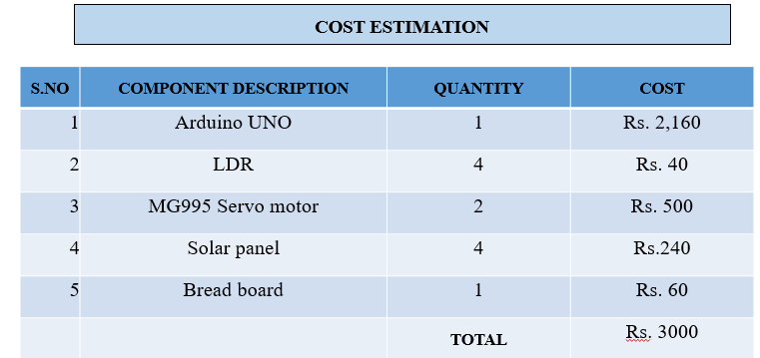

**Table 3.3** Cost Estimation

**CHAPTER 4**

**FUTURE SCOPE & ITS IMPLEMENTATION PLAN**

Solar trackers have both a horizontal and a vertical axis and they can track the sun’s apparent motion virtually anywhere in the world. CSP applications using dual axis tracking include solar power tracker and dish systems. In future this Tilting mechanism with collector can be implemented on large solar plants and also can be operated automatically. It can make the work very easy with the help of electric tilting mechanism. Working on the same to implementing automation for same mechanism with electric or mechanical actuators or components. This mechanism can be implemented on the Solar Cookers, Ovens, and Driers and on thermal solar heater. The main advantage of such systems is maximum amount of power generated due to the biaxial motion. The total cost of tilting and tracking mechanism is less than the 25% that of cost of panel required to generate the same power. It produces 2.5 times more power than regular position of the solar panel. The purpose of the proposed paper is to implement Bi-Axial system with collector effectively. The designed tracker for sun rays is found worked efficiently. The bi-axial tracking apparatus was found more effective than the single axis tilting mechanism. Due to use of collector on the panel the performance of the panel is doubled. The extracted power was observed to have increased significantly by using Bi Axial tilting Mechanism. The same mechanism can be used for solar apparatus like oven, cooker, heaters, etc.

**REFERENCES:**

1. Wirfs-Brock, Jordan. “Energy Explained: Where Does It Come From And How Much Do We Use?” Inside Energy, Inside Energy, 19 Dec. 2017.
2. Urry J. (2015) Climate Change and Society. In: Michie J., Cooper C.L. (eds) Why the Social Sciences Matter. Palgrave Macmillan, London .
3. Phillips, Melissa C. K. “The Effect of Climate Change on Natural Disasters: A College Student Perspective.”.
4. Hsiang, Solomon, et al.“Estimating Economic Damage from Climate Change in theUnited States.” Science, American Association for the Advancement of Science, 30 June 2017.
5. Griscom, Bronson W., et al.“Natural Climate Solutions.” PNAS, National Academy of Sciences, 31 Oct. 2017.
6. Sampaio, Priscila G. V., and Mario O. A. Gonzales. “Photovoltaic Solar Energy: Conceptual Framework.”RenewableandSustainableEnergy Reviews,Pergamon, 2 Mar. 2017.
7. Scheulov, Ivan. “US9379269B2 - Bifacial Crystalline Silicon Solar Panel with Reflector.” Google Patents, Google, 29 Aug. 2013.